LOOP THROUGH HISTORY at Wrightsville Beach - Sponsorship Form
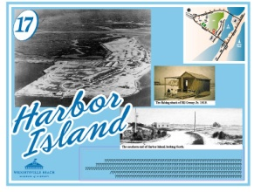
Become a sponsor of one of the 25 signs around the 2.45 miles of The Loop to support the Wrightsville Beach Museum and be a part of this great project. You may sponsor in your name, that of your business, or to honor someone special. We encourage you to be creative. Sponsorships are renewed annually and begin January 1 to run for a calendar year. List of Signs are on reverse. Ones in BLUE are sponsored as of this printing.

Sponsorship annual fee - $150.00 Would you like to automatically receive a renewal notice next year?_______

Sign Number and Title - _____________________________________
How you want the sponsorship/to honor designation to appear: _____________________________________________
Your Name ___________________________________ Email _________________________Phone___________________
Mailing address__________________________________________________________________
Visa or MasterCard card number ____________________________ expiration - __/___ 3-digit code - _______
Or make check out to Wrightsville Beach Museum and mail to P.O. Box 584, Wrightsville Beach, N.C. 28480.

Questions? Call 910-256-2569 or email: wbmuseum@bizec.rr.com. Website: wbmuseumofhistory.com
Wrightsville Beach Museum is located at: 303 West Salisbury Street, Wrightsville Beach, N.C.
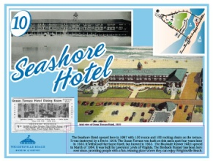
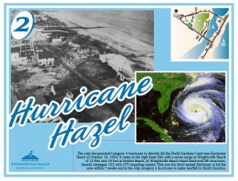
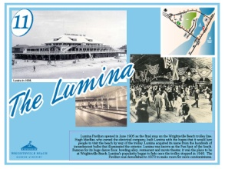
Your sponsor name will go directly on the sign on an oval label that is easy to read.

The Loop Through History Site Signs

Each of the 25 signs around the 2.45 miles of The Loop highlights an important aspect of Wrightsville Beach history and development. Carefully researched and paired with photographs illustrating what was once here, the site signs tell the rich and varied story of Wrightsville Beach. Become a Loop Through History sign sponsor and support the Wrightsville Beach Museum through this exciting new project!

- Wrightsville Beach Museum
- Hurricane Hazel – Sharkey's and Sarah Harris of Intracoastal Realty
- Tidewater Power Company
- Fishing/Marsh and Sea Harvesting
- Wrightsville Beach School
- Bridges
- Wrightsville Beach Then and Now
- Ocean Piers
- Oceanic Hotel
- Seashore Hotel/Ocean Terrace/ Blockade Runner – Mary and Bill Baggett
- Lumina – The family of Pete and Joan Manolukas
- Business District – Sarah Wright Hicks – waterwayproperties.com
- Carolina Yacht Club – Carolina Yacht Club Board of Directors
- Municipal Docks
- Banks Channel – Lisa Weeks
- Research Facilities
- Harbor Island
- Trolley – Susan Creasy
- The Inlets/Jetties
- Bathing Suits – John Sideris
- Lifeguards – Steve Matthews, Matthews Motors
- Police
- Fire Department
- The Drawbridge – William and Debi Beverage
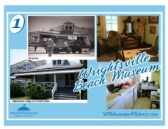
- Babies Hospital – Dr. Anne Allen, Allen Spine and Sports Medicine
