New Spaces – New Uses

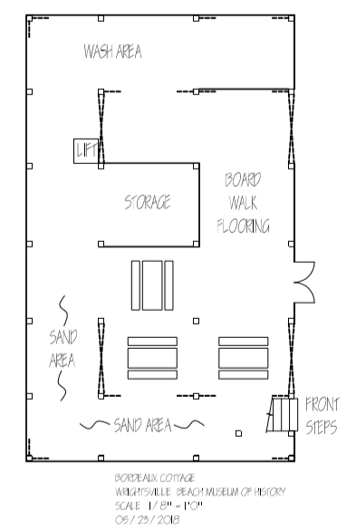
GROUND LEVEL
The Clubhouse - We will have current professionals and artisans demonstrating their skills and knowledge: a boat builder fitting planks over the ribs of a boat, a fisherman weaving a shrimp or fish net, a shaper forming a surfboard. A monthly program held here will be How Did You
Do That? on heritage maritime traditions that are directly linked to local coastal life and history.

Investigation Classroom – This will be a more enclosed area for more traditional classroom work, as well research and hands-on activities. New exhibit panels in the classroom will complement the planned programming by featuring skills and traditions of our local maritime heritage. Camp Chris Stone will use this space and The Clubhouse space.

Outboard Motor Exhibit – The museum has several vintage outboard motors in storage that will be a very interesting display now that we will have more space.

Wash-off Area and Cubbies – for use during Camp Chris Stone and other outdoor activities during Elementary Explorations and Kids Club programs.

Storage Area – to store equipment and supplies as needed.

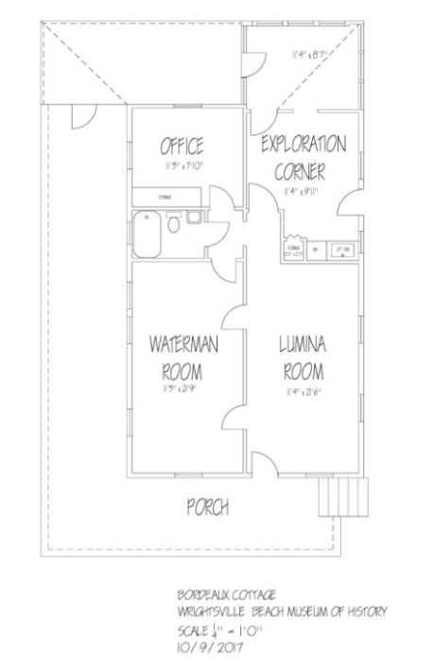

SECOND LEVEL
The Waterman Room with open space that will hold a variety of types of movable exhibit panels and technology as well as can be used for showing movies and holding talks.

The Lumina Room will have our outstanding new Lumina exhibit and a new exhibit on Barrier Islands. Here we will have rotating exhibits that link our past to our present.
Chris Stone Exploration Room for more hands-on activities for children and adults.
Capital Campaign Costs
Phase I and II - $235,000 - COMPLETED – to move, secure, and stabilize the building
Phase III - $50,000 - COMPLETED – To Upfit all systems, install lift, Electrical box, etc. for Certificate of Occupancy and Installation of a Lift. Work to be completed May 2020

